OUTBREAK X
End-to-End Data Analytics, Machine Learning & Deployment
Technical Project Documentation
Project Objective
Build an end-to-end pipeline that connects to a MySQL outbreak database, prepares patient/case information, engineers clinically meaningful features, trains classification models to predict high severity, evaluates the models, interprets the final Random Forest, and exposes the prediction workflow through a Streamlit application.

This document is designed as a detailed reference for the project team. It explains not only what each block of code does, but also why it was used, how the blocks connect together, what outputs were observed, and what issues were encountered during development.

Project Snapshot
Item | Project Detail
Database | MySQL database: outbreak_x_final
Main tables used | final_Patient, final_Medical_History, final_Case, final_Case_Symptom
Primary task | Binary classification: predict High_Severity (0/1)
Candidate models | Logistic Regression and Random Forest Classifier
Training/Test split | 80% / 20%, stratified by target
Rows used for modeling | 600,000 total; 480,000 train; 120,000 test
Encoded feature count | 26 features after one-hot encoding
Target distribution | 16.6% High Severity, 83.4% Not Severe
Best observed model for Severe detection | Random Forest
Deployment | Streamlit application + Joblib artifacts

Table of Contents
1. Project Overview and Objectives
2. Data Sources and Database Connectivity
3. Data Extraction
4. Feature Engineering
5. Data Integration (Merge Pipeline)
6. Missing-Value Handling and Feature Preparation
7. Target Engineering and Modeling Dataset
8. Categorical Encoding and Train/Test Split
9. Model Training
10. Model Evaluation and Interpretation
11. ROC Curve Visualization
12. Feature Importance and Permutation Importance
13. Model Artifact Saving
14. Streamlit Application and Deployment Flow
15. Problems Encountered and Solutions
16. Limitations, Risks, and Recommended Improvements
17. Final Project Workflow
18. Presentation-Ready Talking Points
Appendix A. Important Variables and Their Meanings
Appendix B. Key Code Map

1. Project Overview and Objectives
The project is an end-to-end healthcare/outbreak analytics workflow. The starting point is a relational MySQL database containing patient information, clinical cases, symptoms, and medical history. The final output is a machine-learning system that estimates whether a case is High Severity at diagnosis and exposes the trained Random Forest model through a simple Streamlit user interface.
The project combines four layers: (1) data access and extraction, (2) data preparation and feature engineering, (3) model training and evaluation, and (4) deployment and user interaction. Keeping these layers connected is important because the model must receive new inputs in exactly the same feature format used during training.

Main Objectives
- Connect Python to the MySQL database and retrieve the required tables into Pandas DataFrames.
- Create useful analytical features such as age, symptom counts, severity scores, chronic-condition counts, and days to diagnosis.
- Merge patient-level and case-level information into one modeling dataset.
- Create a binary target called High_Severity, where 1 represents Severe/Critical and 0 represents other severity levels.
- Prepare categorical variables for machine learning with one-hot encoding.
- Train and compare Logistic Regression and Random Forest classification models.
- Evaluate the models using classification report, confusion matrix, ROC-AUC, and ROC curves.
- Interpret which features the Random Forest relied on most heavily.
- Save the trained model and supporting metadata so the prediction application can reuse them without retraining.
- Build a Streamlit interface that accepts patient/clinical inputs and returns a severity prediction plus probability.

2. Data Sources and Database Connectivity
The first stage of the project is establishing a reliable connection between Python and the MySQL database. SQLAlchemy is used to create the database engine, while Pandas uses the engine to execute SQL queries and return results as DataFrames.

2.1 Required Imports
from sqlalchemy import create_engine
import pandas as pd
`create_engine` creates a reusable SQLAlchemy database connection interface. Pandas is required because all later analysis is performed using DataFrames.

2.2 Database Configuration
DB_USER = "root"
DB_PASSWORD = "<local-password>"
DB_HOST = "localhost"
DB_PORT = "3306"
DB_NAME = "outbreak_x_final"
The credentials are configuration parameters. In the project documentation, the actual database password should remain private and should never be hard-coded into a public repository or shared presentation.

2.3 Connection String and Engine
connection_string = f"mysql+pymysql://{DB_USER}:{DB_PASSWORD}@{DB_HOST}:{DB_PORT}/{DB_NAME}"
engine = create_engine(connection_string)
The string specifies the MySQL driver (`pymysql`), the user credentials, host, port, and database name. `create_engine` then builds the database engine that Pandas can use for SQL queries.

2.4 Reusable SQL Loader
def load_query(sql_query: str) -> pd.DataFrame:
return pd.read_sql(sql_query, engine)
This function is a small abstraction around `pd.read_sql`. Instead of repeating the connection logic for every query, the project can call `load_query(...)` with a SQL statement and receive a DataFrame. The type annotation `-> pd.DataFrame` documents the expected return type.

2.5 Connection Validation
if __name__ == "__main__":
test_df = load_query("SELECT * FROM final_Patient LIMIT 5;")
print("Connection is working!")
print(test_df)
The test query retrieves only five rows. This is a lightweight sanity check: if the query succeeds and returns records, the database connection, credentials, driver, and table name are all working together.
Why LIMIT 5?
The goal is not to load the full table just to test connectivity. A small sample reduces runtime and makes the check immediate.

3. Data Extraction
patients = load_query("SELECT * FROM final_Patient;")
medical_history = load_query("SELECT * FROM final_Medical_History;")
cases = load_query("SELECT * FROM final_Case;")
case_symptoms = load_query("SELECT * FROM final_Case_Symptom;")
Four source tables are loaded into memory. Each table represents a different level of information: patient demographics, medical history, case-level information, and case symptoms.
DataFrame | Source Table | Analytical Role | Likely Key
patients | final_Patient | Patient demographics and birth information | Patient_ID
medical_history | final_Medical_History | Chronic diseases and previous conditions | Patient_ID / History_ID
cases | final_Case | Case-level event and diagnosis information | Case_ID / Patient_ID
case_symptoms | final_Case_Symptom | Symptoms and symptom severity per case | Case_ID / Symptom_ID

This separation is important because the source data is relational. A patient may have multiple cases, a case may have multiple symptoms, and a patient may have multiple historical conditions. Before machine learning, these relational structures must be summarized and then merged at the appropriate level.

4. Feature Engineering
Feature engineering converts raw database values into variables that are more useful for analytics and machine learning. In this project, the main transformations are age calculation, symptom severity scoring, symptom aggregation, chronic-disease severity scoring, and history aggregation.

4.1 Age Calculation
from datetime import date
import pandas as pd
def calculate_age(birthdate) -> int:
today = date.today()
bd = pd.to_datetime(birthdate).date()
return today.year - bd.year - ((today.month, today.day) < (bd.month, bd.day))
patients["Age"] = patients["BirthDate"].apply(calculate_age)
The function converts the stored birth date into a date object and calculates age using year, month, and day so that the result is more accurate than simply subtracting the birth year from the current year. The resulting `Age` column becomes one of the model features.
Important modeling note
Because the application later predicts for new users, age calculation is best derived from a birth date or explicitly defined as the age at the relevant diagnosis date. The current project stores a direct age feature for modeling.

4.2 Symptom Severity Encoding
severity_map = {"Mild": 1, "Moderate": 2, "Severe": 3}
case_symptoms["Severity_Score"] = case_symptoms["Symptom_Severity"].map(severity_map)
Machine-learning models operate on numeric values, so symptom severity labels are translated into an ordinal score: Mild=1, Moderate=2, Severe=3. This preserves the intended ordering of the severity levels.

4.3 Symptom Aggregation by Case
symptom_summary = case_symptoms.groupby("Case_ID").agg(
Symptom_Count=("Symptom_ID", "count"),
Avg_Symptom_Severity=("Severity_Score", "mean"),
Max_Symptom_Severity=("Severity_Score", "max"),
).reset_index()
A case can have multiple symptom rows. The groupby aggregation compresses these rows into one case-level summary. `Symptom_Count` measures the number of recorded symptoms; `Avg_Symptom_Severity` measures the average symptom severity; and `Max_Symptom_Severity` captures the most severe symptom in the case.

4.4 Medical-History Severity Scoring
disease_severity_map = {"Mild": 1, "Moderate": 2, "Severe": 3}
medical_history["Disease_Severity_Score"] = medical_history["Disease_Severity"].map(disease_severity_map)
The same ordinal mapping is applied to disease severity in the medical-history table.

4.5 Medical-History Aggregation
history_summary = medical_history.groupby("Patient_ID").agg(
Max_Chronic_Severity=("Disease_Severity_Score", "max"),
Chronic_Disease_Count=("History_ID", "count"),
).reset_index()
History can contain multiple records per patient. The aggregation creates patient-level features: the maximum recorded chronic-disease severity and the number of history records/chronic conditions represented in the source table.

4.6 Extracting the Most Severe History Record
worst_disease = (
medical_history.sort_values("Disease_Severity_Score", ascending=False)
.drop_duplicates(subset="Patient_ID", keep="first")
[["Patient_ID", "Chronic_Disease", "Previous_Conditions"]]
)
The table is sorted from highest disease severity to lowest. `drop_duplicates(... keep="first")` then keeps the first, most severe history row for each patient. This creates a compact patient-level representation containing the chronic disease and previous-condition labels associated with the strongest severity record.

5. Data Integration (Merge Pipeline)
Once each source table has been summarized at the correct grain, the project merges the information into a single modeling DataFrame named `df`. The key idea is to use the identifier that matches the level of the data: `Patient_ID` for patient-level information and `Case_ID` for case-level information.
df = cases.merge(
patients[["Patient_ID", "Age", "Gender", "Occupation"]],
on="Patient_ID", how="left"
)
df = df.merge(symptom_summary, on="Case_ID", how="left")
df = df.merge(history_summary, on="Patient_ID", how="left")
df = df.merge(worst_disease, on="Patient_ID", how="left")
Merge | Join Key | Purpose
cases + patients | Patient_ID | Attach age, gender, and occupation to each case.
+ symptom_summary | Case_ID | Attach symptom count and symptom severity summaries to each case.
+ history_summary | Patient_ID | Attach chronic-condition severity and count at patient level.
+ worst_disease | Patient_ID | Attach the strongest history record and its descriptive labels.

`how="left"` is intentionally used in each merge. The `cases` table is the primary analytical spine, so every case should remain in the final dataset even if some supporting information is missing. A missing match produces `NaN` values instead of deleting the case.
Merge rule to remember
Patient_ID answers “which patient?” while Case_ID answers “which case?” Using the wrong key can duplicate rows or attach information to the wrong record.

6. Missing-Value Handling and Feature Preparation
After merging, some patients or cases may not have corresponding summary records. Missing values are therefore handled before modeling.

6.1 Creating Days_To_Diagnosis
df["Days_To_Diagnosis"] = (
pd.to_datetime(df["Diagnosis_Date"]) -
pd.to_datetime(df["Symptom_Onset_Date"])
).dt.days
The result is a numeric feature representing the number of days between symptom onset and diagnosis. Converting both columns with `pd.to_datetime` ensures that subtraction is performed as a date operation. `.dt.days` converts the time difference into an integer day count.

6.2 Filling Missing Values
df["Max_Chronic_Severity"] = df["Max_Chronic_Severity"].fillna(0)
df["Chronic_Disease_Count"] = df["Chronic_Disease_Count"].fillna(0)
df["Chronic_Disease"] = df["Chronic_Disease"].fillna("None")
df["Previous_Conditions"] = df["Previous_Conditions"].fillna("None")
df["Symptom_Count"] = df["Symptom_Count"].fillna(0)
df["Avg_Symptom_Severity"] = df["Avg_Symptom_Severity"].fillna(0)
df["Max_Symptom_Severity"] = df["Max_Symptom_Severity"].fillna(0)
Numeric fields are filled with zero where zero has a meaningful interpretation in the project context, such as “no recorded chronic-condition severity” or “no summarized symptoms.” Text fields are filled with `None` to represent the absence of a recorded condition.
Caution
The correctness of `fillna(0)` depends on the data meaning. Zero should only be used when missingness logically means “none / no recorded value.” It should not be applied blindly to every numeric column.

7. Target Engineering and Modeling Dataset

7.1 Binary High_Severity Target
df["High_Severity"] = df["Severity"].apply(
lambda x: 1 if x in ("Severe", "Critical") else 0
)
`High_Severity` is the target variable. Severe and Critical are grouped into class 1, while other severity labels are grouped into class 0. This converts a multi-class severity problem into a binary classification task that is easier to evaluate and deploy.
Target definition
Class 0 = Not Severe; Class 1 = High Severity. In the observed dataset, the target distribution was approximately 83.36% class 0 and 16.64% class 1.

7.2 Feature List
FEATURE_COLUMNS = [
"Age", "Gender", "Occupation",
"Symptom_Count", "Avg_Symptom_Severity", "Max_Symptom_Severity",
"Max_Chronic_Severity", "Chronic_Disease_Count",
"Chronic_Disease", "Previous_Conditions",
"Days_To_Diagnosis",
]
TARGET_COLUMN = "High_Severity"
The `FEATURE_COLUMNS` list defines exactly which predictors are available to the model. Explicitly listing them makes the pipeline reproducible and prevents unrelated columns from accidentally entering training.

7.3 Modeling DataFrame
model_df = df[FEATURE_COLUMNS + [TARGET_COLUMN]].copy()
`model_df` is a clean modeling table containing only the selected predictors plus the target. `.copy()` creates an independent DataFrame rather than a view into the original `df`.

7.4 Quick Validation Checks
print(model_df.shape)
print(model_df.head())
print(model_df["High_Severity"].value_counts(normalize=True))
The observed modeling dataset contained 600,000 rows. The target distribution was about 0.83363 for class 0 and 0.16637 for class 1. This is class imbalance, but it is not automatically a data error; it simply means evaluation should not rely on accuracy alone.

8. Categorical Encoding and Train/Test Split

8.1 Categorical Variables
categorical_columns = [
"Gender", "Occupation", "Chronic_Disease", "Previous_Conditions"
]
These columns contain categories such as Female/Male, job types, chronic-disease labels, and previous-condition labels. Most scikit-learn estimators require numeric inputs, so these categories are encoded.

8.2 One-Hot Encoding
model_df_encoded = pd.get_dummies(
model_df,
columns=categorical_columns,
drop_first=True
)
`pd.get_dummies` creates binary indicator columns such as `Gender_Male` or `Occupation_Engineer`. `drop_first=True` removes one reference category per categorical variable, reducing redundancy and dimensionality.

8.3 X and y
X = model_df_encoded.drop(columns=[TARGET_COLUMN])
y = model_df_encoded[TARGET_COLUMN]
`X` contains the predictor features; `y` contains the target labels. This is the standard supervised-learning structure: inputs X are used to predict outputs y.

8.4 Stratified Train/Test Split
X_train, X_test, y_train, y_test = train_test_split(
X, y, test_size=0.2, random_state=42, stratify=y
)
`test_size=0.2` reserves 20% for testing and leaves 80% for training. `random_state=42` makes the split reproducible. Most importantly, `stratify=y` preserves the target distribution across train and test sets.
Split | Rows | Features | High Severity Rate
Training | 480,000 | 26 | 0.166
Testing | 120,000 | 26 | 0.166

The almost identical 16.6% severe rate in both sets confirms that stratification behaved as intended.

9. Model Training

9.1 Logistic Regression
from sklearn.linear_model import LogisticRegression
log_reg = LogisticRegression(max_iter=1000, random_state=42)
log_reg.fit(X_train, y_train)
log_reg_preds = log_reg.predict(X_test)
log_reg_probs = log_reg.predict_proba(X_test)[:, 1]
`fit()` trains the model. `predict()` returns the final binary class. `predict_proba()` returns class probabilities; `[:, 1]` selects the probability of class 1 (High Severity). `max_iter=1000` provides enough optimization iterations for the large dataset.

9.2 Random Forest
from sklearn.ensemble import RandomForestClassifier
rand_forest = RandomForestClassifier(
n_estimators=200,
max_depth=10,
class_weight="balanced",
random_state=42
)
rand_forest.fit(X_train, y_train)
rf_preds = rand_forest.predict(X_test)
rf_probs = rand_forest.predict_proba(X_test)[:, 1]
Parameter | Value | Purpose
n_estimators | 200 | Build an ensemble of 200 decision trees.
max_depth | 10 | Limit tree depth to reduce excessive complexity/overfitting risk.
class_weight | balanced | Increase the learning weight of the minority class.
random_state | 42 | Make the training process reproducible where randomness is involved.

`class_weight="balanced"` is particularly relevant because High Severity represents only about 16.6% of the observations. The parameter encourages the classifier to pay more attention to the minority class instead of simply favoring the majority class.

10. Model Evaluation and Interpretation

10.1 Reusable Evaluation Function
def evaluate_model(name: str, y_true, y_pred, y_prob):
print(f"\n{'='*60}\nModel: {name}\n{'='*60}")
print(classification_report(
y_true, y_pred, target_names=["Not Severe", "Severe"]
))
print(confusion_matrix(y_true, y_pred))
print(f"ROC-AUC Score: {roc_auc_score(y_true, y_prob):.3f}")
The function standardizes evaluation so that both models are measured using exactly the same metrics. This prevents inconsistent comparisons.

10.2 Logistic Regression Results
Class / Metric | Precision | Recall | F1-score | Support
Not Severe | 0.83 | 1.00 | 0.91 | 100,036
Severe | 0.00 | 0.00 | 0.00 | 19,964
Overall Accuracy | 0.83 |  |  | 120,000

The Logistic Regression model achieved 83% accuracy, but this result is misleading for the project objective because the model predicted every test case as Not Severe. The confusion matrix was [[100036, 0], [19964, 0]]. Therefore, the model detected zero Severe cases and had zero recall for the minority class. The ROC-AUC was 0.684, which indicates some ranking ability in the probability outputs, but the default classification threshold produced unusable Severe detection.
Critical interpretation
High accuracy is not enough in an imbalanced classification problem. A model that predicts the majority class for every case can achieve high accuracy while completely failing the minority class.

10.3 Random Forest Results
Class / Metric | Precision | Recall | F1-score
Not Severe | 0.88 | 0.78 | 0.83
Severe | 0.31 | 0.49 | 0.38

The Random Forest substantially improved detection of the Severe class. Severe recall rose to approximately 0.49 compared with 0.00 for Logistic Regression. The model therefore identified roughly half of the actually severe cases, although it still missed a substantial number of them and also generated false positives.

10.4 Random Forest Confusion Matrix
Actual \ Predicted | Not Severe | Severe
Not Severe | 77,931 (TN) | 22,105 (FP)
Severe | 10,246 (FN) | 9,718 (TP)

The confusion matrix shows that 9,718 severe cases were correctly identified (True Positives), while 10,246 severe cases were missed (False Negatives). For this project, False Negatives are especially important because they represent severe cases classified as non-severe.

10.5 Why the Models Were Compared
Logistic Regression provides a simple, interpretable baseline. Random Forest can model more complex, non-linear relationships and, in this project, handled the class imbalance more effectively. The comparison demonstrates why multiple algorithms should be evaluated rather than assuming one model will be best.

11. ROC Curve Visualization
fig, ax = plt.subplots(figsize=(7, 6))
RocCurveDisplay.from_predictions(y_test, log_reg_probs, name="Logistic Regression", ax=ax)
RocCurveDisplay.from_predictions(y_test, rf_probs, name="Random Forest", ax=ax)
ax.set_title("ROC Curve - Model Comparison")
plt.savefig("roc_curve_comparison.png", dpi=150, bbox_inches="tight")
The two models are plotted on the same axes so that their ranking performance can be compared visually. The ROC curve uses predicted probabilities rather than final class labels. The area under the ROC curve (ROC-AUC) summarizes how well the model separates Severe from Not Severe across possible classification thresholds.
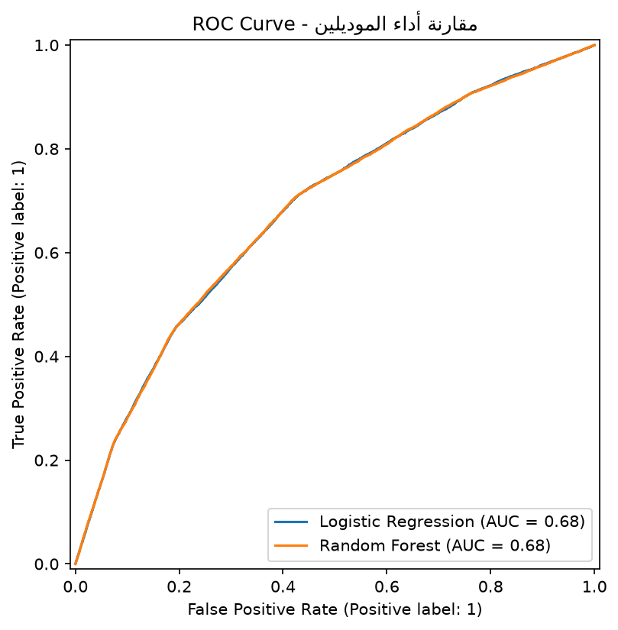
Figure 1“ROC Curve Comparison of Logistic Regression and Random Forest.”
The recorded Logistic Regression ROC-AUC was 0.684. The Random Forest ROC-AUC should be reported from the completed evaluation output alongside the curve rather than inferred from accuracy.

12. Feature Importance and Permutation Importance

12.1 Built-in Random Forest Feature Importance
importances = pd.Series(
rand_forest.feature_importances_,
index=X_train.columns
)
importances_sorted = importances.sort_values(ascending=False)
print(importances_sorted.head(10))
The built-in `feature_importances_` measure reflects how much each feature contributed to impurity reduction across the decision trees. The observed output placed Age first with an importance score of 0.948260, followed by much smaller contributions from Days_To_Diagnosis, Avg_Symptom_Severity, Max_Chronic_Severity, and other variables.
Interpretation rule
A feature-importance score is not a causal percentage. It should not be written as “Age causes 94.8% of severity.” The correct interpretation is that Age was the most influential feature for the trained Random Forest according to this importance measure.

12.2 Feature-Importance Visualization
top_features = importances_sorted.head(10)
plt.figure(figsize=(9, 6))
top_features.sort_values().plot(kind="barh")
plt.title("Top 10 Features - Random Forest")
plt.xlabel("Feature Importance")
plt.tight_layout()
plt.savefig("feature_importance.png", dpi=150, bbox_inches="tight")
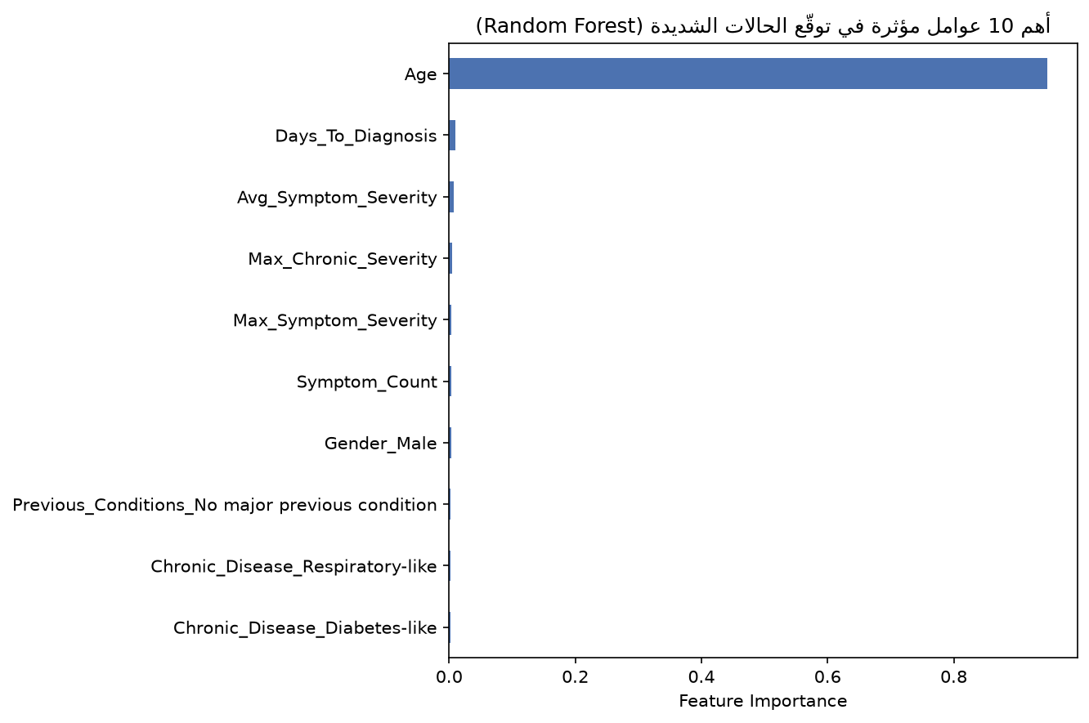
Figure 2“Top 10 Feature Importance Scores from the Random Forest.”

12.3 Validation Checks for Age Dominance
pd.crosstab(df["Age"], df["High_Severity"], normalize="index")
This table answers: “For each age, what proportion of cases are High Severity versus Not Severe?” The observed output showed lower severe rates in many younger age groups and higher severe rates in older age groups, e.g. around 0.38–0.39 for several ages in the mid-to-late 80s.
df.groupby("Age")["High_Severity"].mean().sort_values()
Because High_Severity contains only 0 and 1, the mean within an age group is equivalent to the proportion of severe cases in that group. This provides a direct descriptive check of the age pattern.
df[["Age", "High_Severity"]].corr()
The observed Pearson correlation between Age and High_Severity was approximately 0.252836. This indicates a positive relationship, but it is not a direct statement of causation and it does not need to match Random Forest feature importance numerically.

12.4 Permutation Importance
from sklearn.inspection import permutation_importance
perm_importance = permutation_importance(
rand_forest, X_test, y_test,
n_repeats=5,
random_state=42,
scoring="roc_auc"
)
perm_importances = pd.Series(
perm_importance.importances_mean,
index=X_test.columns
).sort_values(ascending=False)
Permutation importance provides a second perspective. For each feature, the values are randomly shuffled on the test set while the already-trained model remains unchanged. The drop in ROC-AUC indicates how much the model relied on that feature for performance. The observed results again ranked Age far above the other variables, with a permutation importance score of 0.183425.
Feature | Permutation Importance
Age | 0.183425
Gender_Male | 0.000442
Max_Symptom_Severity | 0.000312
Previous_Conditions_Prior outpatient care | 0.000240
Max_Chronic_Severity | 0.000207
Occupation_Self-employed | 0.000173
Occupation_Engineer | 0.000139
Occupation_Unemployed | 0.000123
Occupation_Farmer | 0.000113
Occupation_Teacher | 0.000075

The key conclusion is not that the two importance scores (0.948260 and 0.183425) are numerically comparable. They are different metrics. The meaningful finding is that both methods ranked Age as the dominant predictor, so the model’s dependence on Age is not limited to a single importance calculation.

12.5 Permutation Importance Plot
top_perm = perm_importances.head(10).sort_values()
plt.figure(figsize=(9, 6))
top_perm.plot(kind="barh")
plt.title("Top 10 Features - Permutation Importance")
plt.xlabel("Mean Decrease in ROC-AUC")
plt.tight_layout()
plt.savefig("permutation_importance.png", dpi=150, bbox_inches="tight")
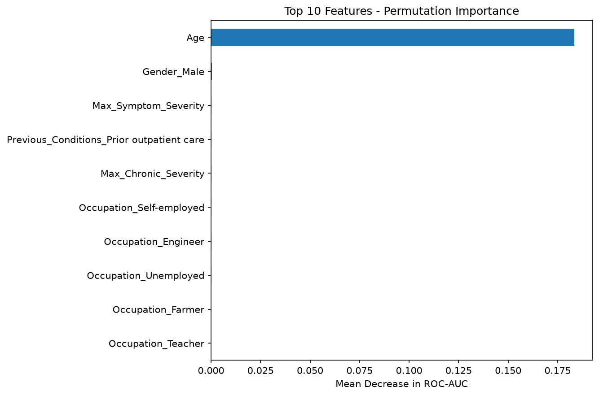
Figure 3“Permutation Importance of the Top 10 Predictors.”

13. Model Artifact Saving
import joblib
joblib.dump(rand_forest, "random_forest_model.pkl")
The trained Random Forest is serialized with Joblib. This avoids retraining every time the application starts.

13.1 Categorical Options Artifact
categorical_options = {
col: sorted(model_df[col].dropna().unique().tolist())
for col in categorical_columns
}
joblib.dump(categorical_options, "categorical_options.pkl")
This metadata file stores the real categories observed in the source data, such as Male/Female, occupation values, chronic-disease labels, and previous-condition labels. The Streamlit interface uses them to populate dropdown menus.

13.2 Numeric Defaults Artifact
numeric_columns = [c for c in FEATURE_COLUMNS if c not in categorical_columns]
numeric_defaults = model_df[numeric_columns].median().to_dict()
joblib.dump(numeric_defaults, "numeric_defaults.pkl")
The median of each numeric feature is stored as a default reference. In the current application, the chronic disease count uses the saved default as its initial value, while several other inputs still use explicit UI defaults.
Artifact | Purpose
random_forest_model.pkl | Serialized trained Random Forest.
categorical_options.pkl | Valid categorical options used by the UI.
numeric_defaults.pkl | Median values used as numeric defaults/reference values.

14. Streamlit Application and Deployment Flow
The final application turns the trained model into an interactive web interface. The user enters patient and clinical data, the application converts those values into the same encoded feature structure used during training, and the Random Forest returns a prediction and probability.

14.1 Page Configuration
st.set_page_config(
page_title="Outbreak Severity Prediction",
page_icon="🦠",
layout="centered"
)
st.title("Outbreak Severity Prediction 🦠")
Streamlit handles the user interface. The page title, icon, layout, header, and explanatory text create the user-facing application shell.

14.2 Loading the Saved Model and Metadata
try:
model = joblib.load("random_forest_model.pkl")
categorical_options = joblib.load("categorical_options.pkl")
numeric_defaults = joblib.load("numeric_defaults.pkl")
except FileNotFoundError:
st.error("Model files are missing from the application folder.")
st.stop()
The app loads the three saved artifacts. The `try/except` block converts a missing-file problem into a clear user-facing error and stops execution safely.

14.3 User Input Controls
The interface uses `number_input`, `selectbox`, `date_input`, `columns`, and `expander` to collect age, gender, occupation, symptom dates, symptom count, symptom severity, chronic disease, chronic-disease severity, chronic-condition count, and previous conditions.

14.4 Converting Severity Labels to Numeric Values
severity_map = {"Mild": 1, "Moderate": 2, "Severe": 3}
severity_map_with_none = {"None": 0, "Mild": 1, "Moderate": 2, "Severe": 3}
The application recreates the ordinal encoding used during training so that the same semantic categories become the same numeric values.

14.5 Rebuilding the Model Input Schema
days_to_diagnosis = (diagnosis_date - symptom_onset).days
encoded_dict = {col: 0 for col in model.feature_names_in_}
The app creates one dictionary containing every feature expected by the trained model and initially sets everything to zero. It then fills in numeric values and activates the appropriate one-hot categorical column for the user’s selected category.

14.6 One-Hot Categorical Reconstruction
gender_col = f"Gender_{gender}"
if gender_col in encoded_dict:
encoded_dict[gender_col] = 1
occ_col = f"Occupation_{occupation}"
if occ_col in encoded_dict:
encoded_dict[occ_col] = 1
The same pattern is used for Gender, Occupation, Chronic_Disease, and Previous_Conditions. This is critical because the production input must match the one-hot representation produced during training.

14.7 Final Input DataFrame and Prediction
input_df_encoded = pd.DataFrame([encoded_dict])[model.feature_names_in_]
prediction = model.predict(input_df_encoded)[0]
prediction_prob = model.predict_proba(input_df_encoded)[0]
`model.feature_names_in_` ensures the columns are in the exact order learned during fitting. `predict` returns the binary class; `predict_proba` returns the probability for each class. The application displays a warning for High Severity and a success message for Not Severe, together with the corresponding probability.

14.8 Application Flow
- Load the trained Random Forest and saved metadata files.
- Render patient and clinical input controls.
- Wait for the user to click Predict Severity.
- Calculate Days_To_Diagnosis from the two dates.
- Encode numeric and categorical inputs into the exact training schema.
- Call predict() and predict_proba() on the trained Random Forest.
- Display the binary classification and probability.

15. Problems Encountered and Solutions
The project involved multiple stages where common data-science and integration problems can occur. The following list documents the key issues that were encountered or identified during the workflow and the practical solution used.
Problem | Cause / Symptom | Solution / Lesson
Database connection uncertainty | Need to verify that Python can access MySQL tables before loading everything. | Use a small `SELECT ... LIMIT 5` test query before running full extraction.
Wrong join level risk | Patient data, case data, symptoms, and history do not all share the same grain. | Use Patient_ID for patient-level summaries and Case_ID for case-level summaries.
Missing values after left joins | A patient/case may have no matching symptom or history summary. | Use targeted `fillna` rules based on the meaning of each column.
Dates stored as non-datetime values | Direct date subtraction can fail or behave incorrectly. | Convert columns with `pd.to_datetime` before subtracting.
Categorical text not accepted directly by model | Columns contain strings such as occupation and gender. | Use one-hot encoding with `pd.get_dummies`.
Class imbalance | High Severity is only ~16.6% of observations. | Use stratified splitting, inspect minority-class metrics, and use `class_weight="balanced"` for Random Forest.
Accuracy looked good but Logistic Regression failed | 83% accuracy hid zero recall for Severe. | Use classification report, confusion matrix, and ROC-AUC; do not rely on accuracy alone.
Age had extremely high feature importance | Random Forest ranked Age far above other variables. | Check descriptive age-vs-target patterns and validate importance with permutation importance.
Model must receive exact feature order | One-hot encoded training schema contains 26 expected columns. | Rebuild input using `model.feature_names_in_` before prediction.
Missing model files in Streamlit | App cannot predict without serialized artifacts. | Use `try/except FileNotFoundError` and keep all .pkl files in the same application folder.

16. Limitations, Risks, and Recommended Improvements

16.1 Class Imbalance
Only about one in six records is High Severity. The project correctly recognized this and used stratified splitting plus balanced class weights for the Random Forest. Still, recall for Severe remained around 0.49, meaning a substantial number of severe cases were missed.

16.2 Feature Importance Is Not Causality
The feature-importance analysis identifies predictive usefulness inside the model, not medical causation. In particular, Age should not be described as “causing” a percentage of severity merely because it has a large feature-importance score.

16.3 Input/Training Consistency
The application recreates training encodings manually. A more robust production pipeline would save the complete preprocessing object (for example, a scikit-learn Pipeline with an encoder) together with the model so that training and inference share exactly the same transformation code.

16.4 Severity Mapping Consistency
The training target groups Severe and Critical together. The Streamlit input mapping currently exposes Mild, Moderate, and Severe labels, while the output message mentions Severe/Critical. This should be reviewed before any real-world use so that training categories and UI categories are fully consistent.

16.5 Date Validation
The current app calculates `Days_To_Diagnosis` directly from the selected dates. A production version should validate that diagnosis date is not earlier than symptom onset and should provide a clear warning when the date sequence is invalid.

16.6 Numeric Defaults
The saved `numeric_defaults` dictionary contains dataset medians, but the current UI still uses hard-coded defaults for several fields. A cleaner design would use the saved defaults consistently across all numeric inputs or explicitly document each UI default.

16.7 Clinical Use Disclaimer
The model is a project prototype for analytics/education. It should not be presented as a clinical diagnostic tool, and its predictions should not replace professional medical judgment.

17. Final Project Workflow
End-to-End Pipeline
MySQL Database → Data Extraction → Feature Engineering → Patient/Case Merge → Missing-Value Handling → Target Engineering → One-Hot Encoding → Stratified Train/Test Split → Logistic Regression + Random Forest → Evaluation → ROC Curve → Feature Importance → Joblib Artifacts → Streamlit Prediction App

Stage | Main Output
Database access | DataFrames: patients, medical_history, cases, case_symptoms
Feature engineering | Age, severity scores, symptom summaries, history summaries
Integration | Unified DataFrame `df`
Model preparation | `model_df`, encoded `X`, target `y`
Splitting | X_train, X_test, y_train, y_test
Modeling | Logistic Regression and Random Forest
Evaluation | Classification reports, confusion matrix, ROC-AUC
Interpretability | Feature importance and permutation importance
Deployment artifacts | Three `.pkl` files
Application | Streamlit `app.py`

18. Presentation-Ready Talking Points

18.1 30-Second Project Explanation
Recommended presentation wording
“We started from a relational MySQL outbreak database and extracted patient, case, symptom, and medical-history data into Pandas. We engineered age, symptom severity, chronic-condition, and diagnosis-delay features, merged them into a modeling dataset, and created a binary High Severity target. We then encoded categorical variables, used a stratified 80/20 split, trained Logistic Regression and Random Forest models, and compared them with precision, recall, F1-score, confusion matrices, and ROC-AUC. Random Forest performed better at detecting severe cases, so we saved it with Joblib and deployed it through a Streamlit application.”

18.2 Key Metrics to Mention
- Dataset size: 600,000 rows used for modeling.
- Train/Test: 480,000 / 120,000 rows.
- Target imbalance: approximately 83.4% Not Severe and 16.6% High Severity.
- Logistic Regression: 0.00 recall for Severe despite 83% overall accuracy.
- Random Forest: approximately 0.49 recall and 0.38 F1-score for Severe.
- Random Forest confusion matrix: TN=77,931, FP=22,105, FN=10,246, TP=9,718.
- Logistic Regression ROC-AUC: 0.684.
- Age ranked as the most influential predictor in both built-in and permutation importance analyses.

18.3 Visuals to Place in Canva
Visual | Suggested location | Purpose
ROC curve: roc_curve_comparison.png | Model evaluation section | Compare probability-ranking performance.
Feature importance: feature_importance.png | Interpretability section | Show which variables Random Forest used most.
Permutation importance: permutation_importance.png | Interpretability validation | Show the performance impact of shuffling each feature.
Streamlit application screenshot | Deployment section | Demonstrate the final user-facing interface.
Confusion matrix screenshot/table | Evaluation section | Explain correct/incorrect classifications.

Appendix A. Important Variables and Their Meanings
Variable | Meaning
Age | Patient age used as a predictor.
Gender | Patient gender category.
Occupation | Patient occupation category.
Symptom_Count | Number of recorded symptoms per case.
Avg_Symptom_Severity | Mean numeric severity across symptoms.
Max_Symptom_Severity | Maximum symptom severity score.
Max_Chronic_Severity | Maximum severity score among chronic/history records.
Chronic_Disease_Count | Count of chronic/history records summarized for the patient.
Chronic_Disease | Category from the most severe history record.
Previous_Conditions | Previous-condition label from the selected history record.
Days_To_Diagnosis | Days from symptom onset to diagnosis.
High_Severity | Binary target: 1=Severe/Critical, 0=otherwise.

Appendix B. Key Code Map
Code Component | What It Does
create_engine(connection_string) | Creates database engine.
pd.read_sql / load_query | Loads SQL query results into DataFrames.
apply(calculate_age) | Creates Age from BirthDate.
map(severity_map) | Converts severity labels to numeric scores.
groupby().agg(...) | Summarizes multiple symptom/history records.
merge(..., how="left") | Combines patient, case, symptom, and history information.
fillna(...) | Handles missing values according to column meaning.
pd.get_dummies(...) | One-hot encodes categorical features.
train_test_split(..., stratify=y) | Creates reproducible, class-balanced train/test partitions.
fit(...) | Trains a machine-learning model.
predict(...) | Returns the final class label.
predict_proba(...) | Returns class probabilities.
classification_report(...) | Precision, recall, F1, support.
confusion_matrix(...) | Counts TN, FP, FN, TP.
roc_auc_score(...) | Computes ROC-AUC from probabilities.
RocCurveDisplay.from_predictions(...) | Plots ROC curves.
feature_importances_ | Built-in Random Forest importance measure.
permutation_importance(...) | Measures performance drop when feature values are shuffled.
joblib.dump / load | Saves/loads trained model and metadata.
st.* | Builds the Streamlit user interface.

Final Note
The project demonstrates a complete analytics-to-deployment workflow rather than an isolated model-training exercise. The strongest lesson is that a machine-learning model is only one part of the system: data quality, feature definitions, class balance, evaluation methodology, reproducibility, and input consistency are equally important to producing a credible result.

